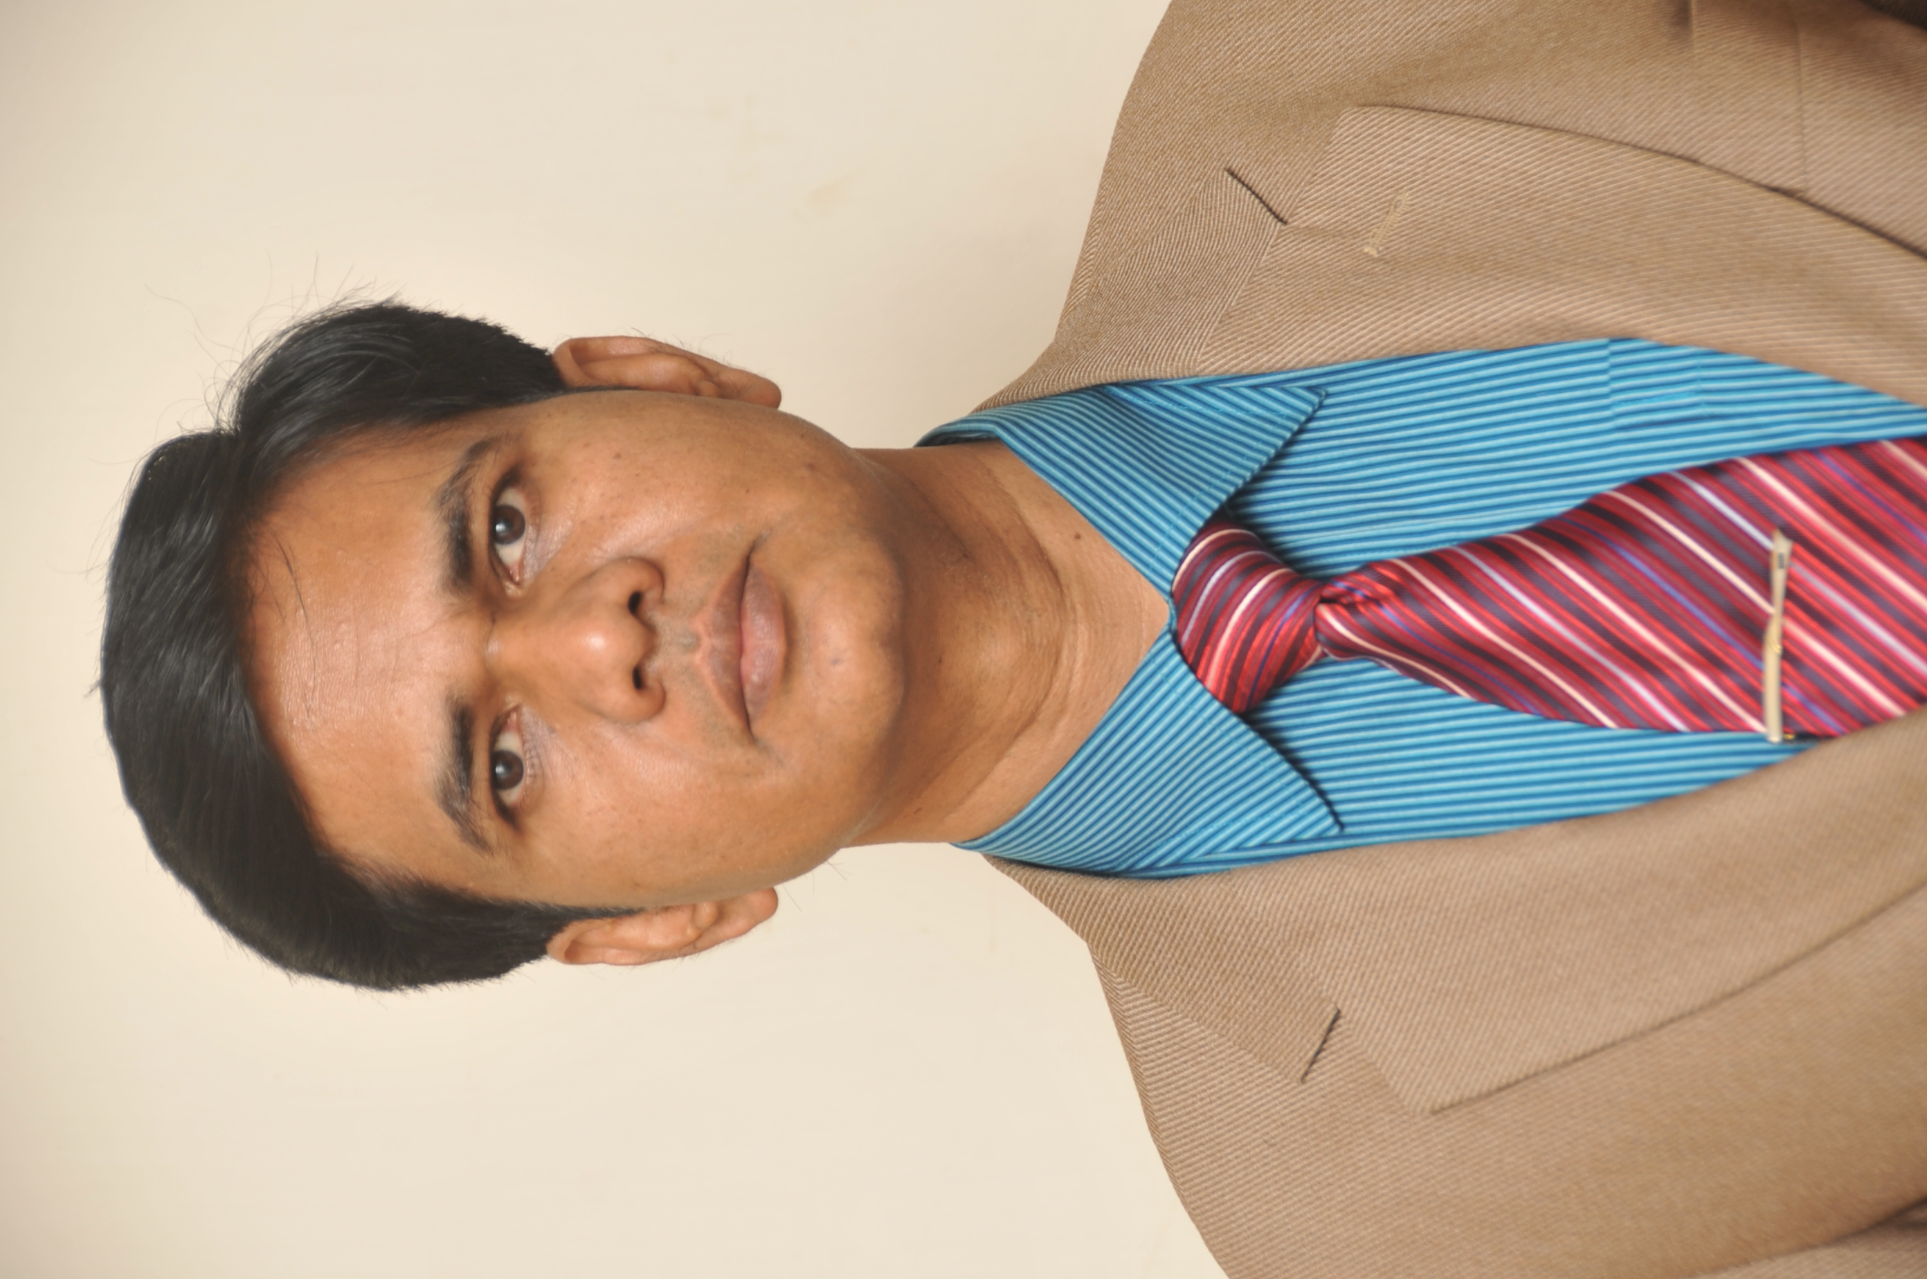

Resume

OF

Dr. S.M. Rafiqul Islam

Educational background:

Name of Degree/Certificate | Year of Passing | Division/grade | Major
Master of Science (MS) | 2018 | A-Grade | Microbiology
Master’s in Public Health(MPH) | 2007 | A-Grade | Population and Reproductive Health
Bachelor of Medicine & Bachelor of Surgery | 1989 | Passed | Medicine and surgery
Higher Secondary Certificate | 1981 | 1st Div | Science
Secondary school Certificate | 1979 | 1st Div | Science

Professional Training/courses:

- Six month Post Graduate Training in Cardiology in Bangabandhu Sheikh Mujib Medical University(ex-IPGM&R) from 01.07.94 to 31.12.94
- Six month Post Graduate Training in Internal Medicine in Shaheed Suhrawardy Hospital at Dhaka from 15.05.2001 to 20.11.2001
- Certificate Course on Diabetology (CCD) from BIRDEM under curriculum of University of London and accreditation as Diabetologist.
- Global Outbreak Alert and Response Network (GOARN) training that was organized by the WHO Regional Office for the Eastern Mediterranean (EMRO) at Dead Sea, Jordan on 25-31 March 2014.
Professional Experience:

Recent past employer: International Centre for Diarrheal Disease Research, Bangladesh (icddrb); Mohakhali; Dhaka-1212
(From 2001 to .2025)
Position: Head, Gastrointestinal Unit , Dhaka Hospital ,icddrb

2001 to 2017:
Position: Senior Medical Officer
Responsibilities:
1) To participate in activities related to patient care at Dhaka Hospital of icddrb under Nutrition and Clinical Services Division (NCSD)
2) To supervise the physicians-clinical fellows and other relevant staffs on diarrheal disease management, documentation of co- morbidities of MAM and SAM children in NCSD
3) Assist Chief Physician and Head, Hospitals, along different line for unit management to ensure sustained better patient care in NCSD.
4) Supervise the hospital infection control team (doctors, nurses, health workers, cleaners and attendants) to ensure the proper infection control and prevention policy in the unit
5) Generating research protocol and ideas on diarrheal disease and relevant topic to potentiate research activities in NCSD.
6) Special assignments: Taking part with GOB in the post - outbreak investigation team member of National outbreak policy

Research Experiences:
- Principal Investigator:
Research Project Name: Activating Faith Communities and Empowering "ORS moms" in Nigeria
Responsibilities: 1. Proposal writing
2. IRB and ERC facing
3. Budget preparation
4. Staff hiring and training through HR
5. Collaboration (overseas)
6. Field work in Nigeria( training of TOT)
7. Monitoring and evaluation of project progress
7. Arranging seminar and conference

Project duration: Sept. 1, 2013-Aug. 30, 2014

- Co-Principal Investigator: A pilot study to assess the acceptability and efficacy of ‘fish Surimi peptide’ in 2 to 5 years old children suffering from moderate acute malnutrition
1. Proposal writing
2. IRB and ERC facing
3. Budget preparation
4. Staff hiring and training through HR
5. Data monitoring and processing
6.Data analysis ( by SPSS)
7. Manuscript writing – under process to submit in journal.

Other experiences:
- Consultant-Cholera Case management in South Sudan (From: 25 June-17July, 2014)

I was asked by WHO’s Global Outbreak and Response Network (GOARN) to participate in the Emergency task force to set up and to to assist the South Sudan government in the growing cholera outbreak in 2014 and 2015 in suggesting the preparedness the outbreak and Control measures taken in different state of the country. I joined the task force on a three-week mission, during which I worked closely with those respective governments and Ministry of Health (MOH) providing technical support to undertake a rapid assessment of the cholera situation. I, with the team of experts visited hospitals and clinics in affected areas as well as rural hospitals in those states conducting surveillance and analysis to confirm the reported cholera cases. Analyzing the capacitates and future requirements of the health facilities like DTC, ORTs, and related need health professionals, IPC Officers and other capacities personnel.
I, with the task force also assisted the MOH in developing a draft cholera response plan and intensifying cholera response activities in the affected areas. Training was also provided by me to the MOH and private health workers on outbreak control and prevention, surveillance methods, case management, infection prevention and control, social mobilization and awareness on community management of water and sanitation systems and family based personal hygiene methods.
I recommended MOH officials to ensure widespread distribution of ORS at the community level and to provide training to the primary health workers on its use so that any small change can bring about certainly a big impact.

- Consultant-Cholera Case management in Iraq (From 10 Oct-24 Oct 2015)

Global Outbreak and Response Network (GOARN) to participate in the Emergency task force

- Consultant-Cholera Case management in Tanzania(From 30 Nov-16 Dec 2015)

Global Outbreak and Response Network (GOARN) to participate in the Emergency task force

Research paper presented in the following countries:
- Japan
- Australia
- Norway
- United Kingdom

From 1996 to 2000
Rumah General Hospital, Riyadh,KSA
Position: Resident Physician
Major Responsibilities:
- Worked in Artificial Kidney Unit to conduct haemo-dialysis to the patients who needed dialysis
- To manage and treat kidney diseases suspected patients in outdoor and inpatient

From 1991 to 1996
Monowara Hospital(Pvt)Ltd, Dhaka
Position: Medical Officer
Responsibilities:
- To treat and manage of indoor, outdoor and emergency department patients
- To make round in the ward with renowned consultants to see the admitted patient in the hospital
- To refer the critical cases in respective unit and hospitals

Personal information:
Present and Mailing Address: 726/22 Baitul Aman Housing Society . Road -10, Adabor, Dhaka -1207
Date of Birth: 30.06.1964
Marital Status: Married
Language known: Bangla(mother tongue); English(Fluent-spoken and written). Arabic- Fluent spoken

